WAD SECOND ASSESSMENT REPORT

Konstantin Milchev

51663558

**Tic-Tac-Toe**

1. ***Vision***

The purpose of this project is to provide terminal and web versions of the famous game tic-tac-toe. The web application includes an authentication system.

1. ***Features and functionalities***

The three stages of the project are located inside the wad2 folder. Firstly, the folder “tests passed” contains the spec file and the edited gen file. There is a folder separation as there had to be changes made to the gen file in order for the full program to run in the terminal and the web. *Screenshot 1(*Appendix) displays what occurs after the “rspec wad_oxo_spec_01.rb” command is run.

The “terminal running” file contains a run and a gen file which only contain the terminal version. Thus, option 2 in the menu does not produce an output.

The wad2/wad_oxo_gen_01.rb and wad2/wad_oxo_run_01.rb files are the complete version of the project. Thus, option 1 and 2 are producing outputs.

**Terminal**: If you would like to see the terminal version please run the wad2/wad_oxo_run_01.rb file. After it has begun please select the first option for the terminal based game. This will take you to a three option menu with “Start Game”, “New Game” and “Exit”. At the beginning you can select one of three options

* Start game
* New game
* Exit

*Please have a look at Screenshot 2*

You can either start with “New Game” or “Start Game”. The difference between these options is that “Start Game” keeps the scores and “New Game” resets them. You receive an output of the scores after each game has finished. You also receive the same menu with the three options as mentioned above. You can keep playing until you are finished and if you wish to exit select option “9 – exit” and this will take you at the folder location command line. If you are confused and cannot run the game yet, an explanation will be provided in section 4.

After you start the game you will be displayed a matrix with numbers in it. Those numbers correspond to a specific field. Thus ,after you are prompted for an input , input the number you with to mark with an “O” or “X” depending on which player you are and press enter.

*Please have a look at Screenshot 3 and 4*

As you can see this way you mark fields.

Additional details about how to run the file are provided in section 4.

**Web:** After you follow the steps in section 4 you will find yourself in your web browser with this screen.

*Please have a look at Screenshot 5*

You have three options:

* Home
* Register
* Login

Underneath the yellow buttons you will see that the home screen suggests registering and logging in in order to play the game. After you follow these steps you will find yourself with this home screen.

*Please have a look at Screenshot 6, 7 and 8*

The new options include

* New Game
* Reset Game

You start a new game and an interface with scores and tic – tac – toe fields appears.

*Please have a look at screenshot 9*

You have scores at the top of the page, a table key showing which keys correspond to which fields so it makes it easy for you to play, a table status, which updates after every move you make and a *move* field, which takes in an input and converts it to an “O” or “X”. After you try to enter something in the *move* field you will notice that it only takes in numbers from 1 – 9. After you select a move, the table will show it and the next player will be ready for his turn.

*Please have a look at Screenshot 10*

After you and your friend/opponent are finished you can press *Restart Game* in order to reset the scores.

The application includes an additional option of a user “Admin” with a password “password”. This super user can delete other users.

1. ***Difficulties report***

There were not too many difficulties creating the terminal application and the web based application. If there was more time a record of wins would have been recorded.

1. ***Running the application***

Windows users*

If you would like to run the application you would need to download one of the versions of ruby available on railsinstaller.org

After this is complete you would need do download these gems by running the command: *gem install gem-name-here*

* sinatra
* data_mapper
* dm-sqlite-adapter
* sqlite
* haml
* rspec

Next, you would need to press the windows button and write down *cmd* in order to find the terminal through which a command will be entered and the application ran.

When cmd is opened it will display a directory, place the project file inside that directory. Afterwards, write down the command *cd wad2* This should open the folder project inside the original directory.

After the *cd wad2* command you will be inside of the wad2 directory. You have 3 options as stated above

* Type “cd tests passed” in order to go into the testing directory and input *rspec wad_oxo_spec_01.rb* in order to test the gen file in the same folder.
* Type *cd terminal runing* and *wad_oxo_run_01.rb* in order to open the terminal. Notice that it was mentioned that option 2 for the web based application is not working in this folder. Another way of running the terminal is typing *ruby wad_oxo_run_01.rb* when in the wad2 folder and selecting option 1 for the terminal version.

In order to run the entire project

* + If located in wad2/ write down *ruby wad_oxo_run_01.rb*
  + If located in *terminal running* or *tests passed* on the terminal input *cd..* in order to go back to the wad2 folder input “ruby wad_oxo_run_01.rb” and select either option 1 for terminal or option 2 for web based. If option 2 is selected then open a web browser and type in the searchbar: *localhost:4567* That should do it. Your code should be working and displaying pages as the ones in the screenshots. If you started from this step please go to step 2 in order to comprehend how the software operates.

1. ***Additional Info***

There are also 2 other folders in the wad2 folder.

* Views
* Public

Inside the Public foder there is the css file style and the image for the homepage of the application. Inside the Views folder there are the different .erb files for the different pages of the application.

***Appendix***

This section includes the screenshots for the game.

Screenshot 1

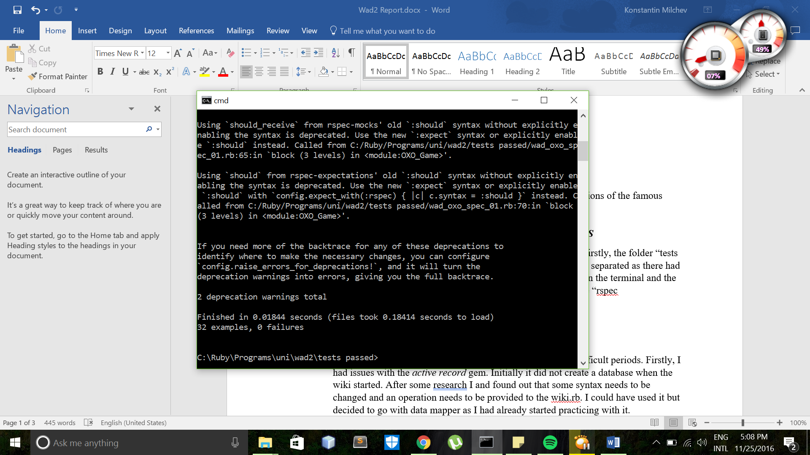

Screenshot 2

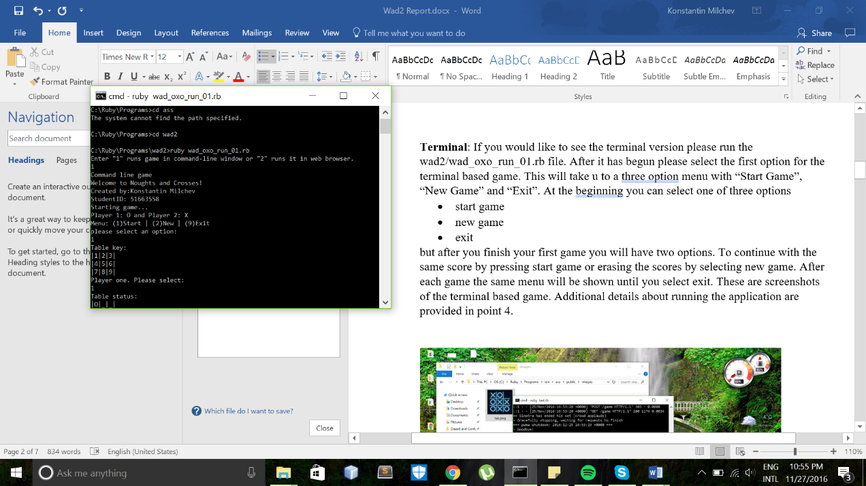

Screenshot 3

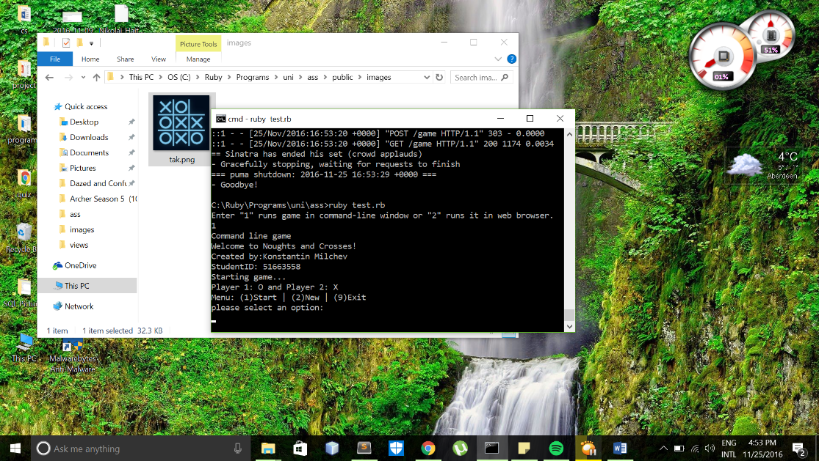

Screenshot 4

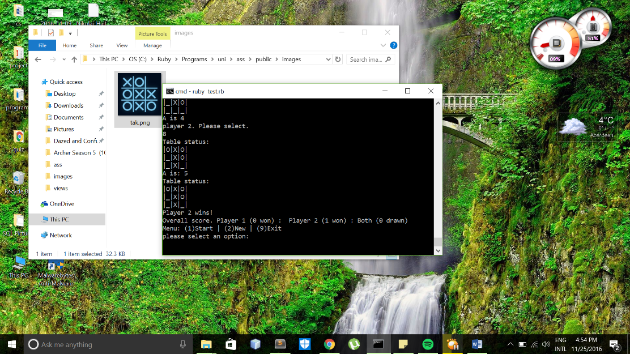

Screenshot 5

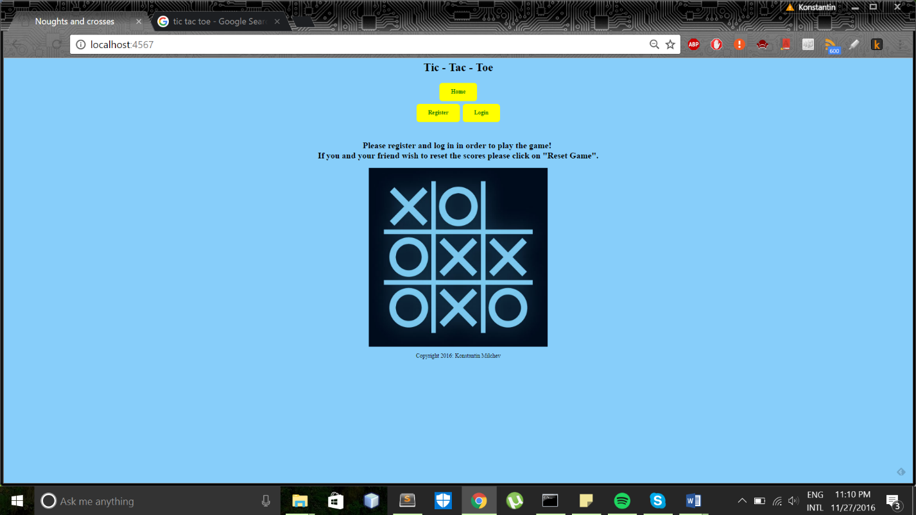

Screenshot 6

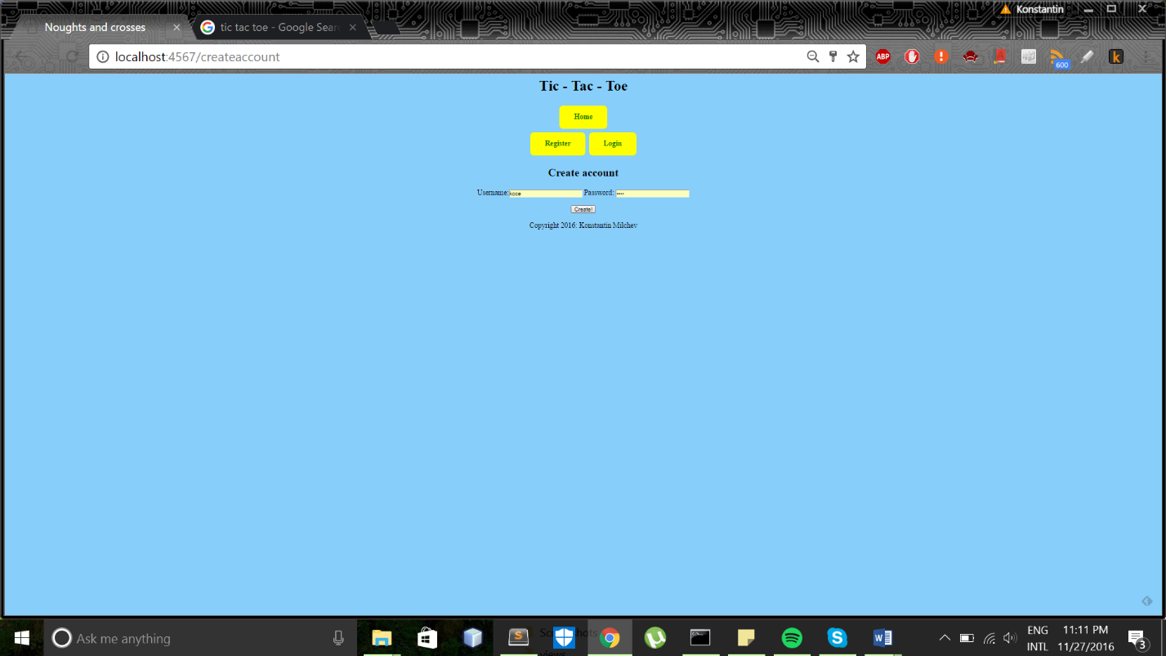

Screenshot 7

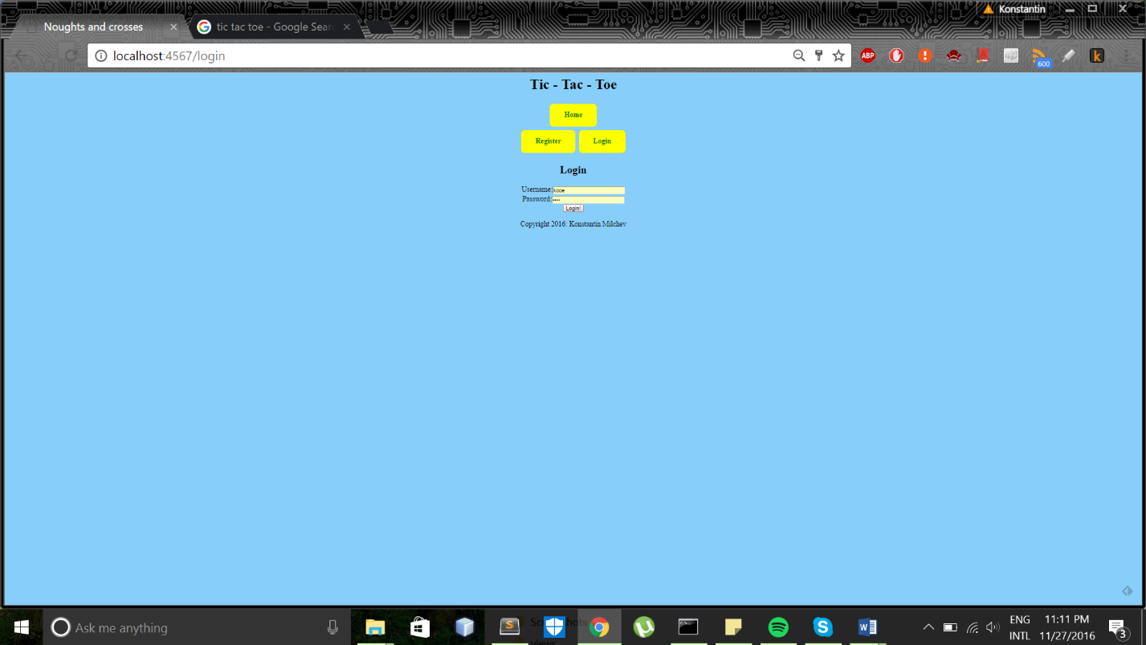

Screenshot 8

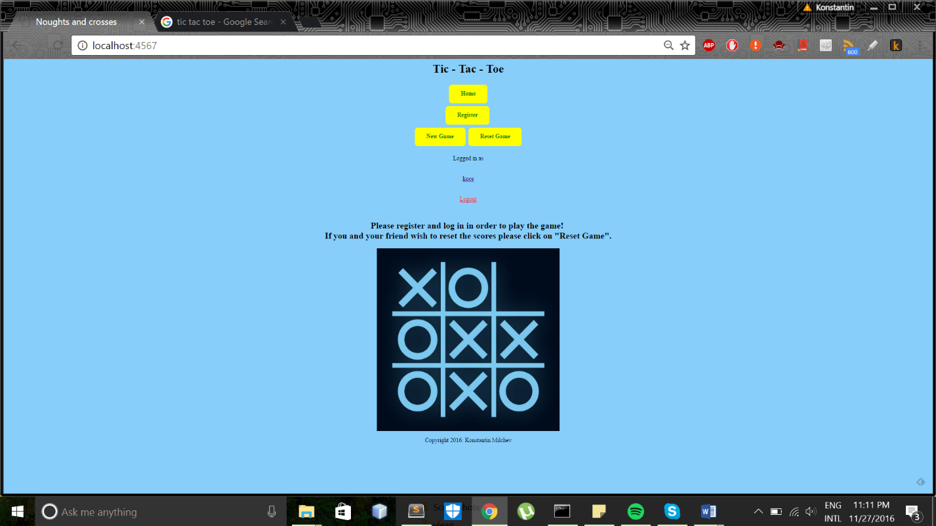

Screenshot 9

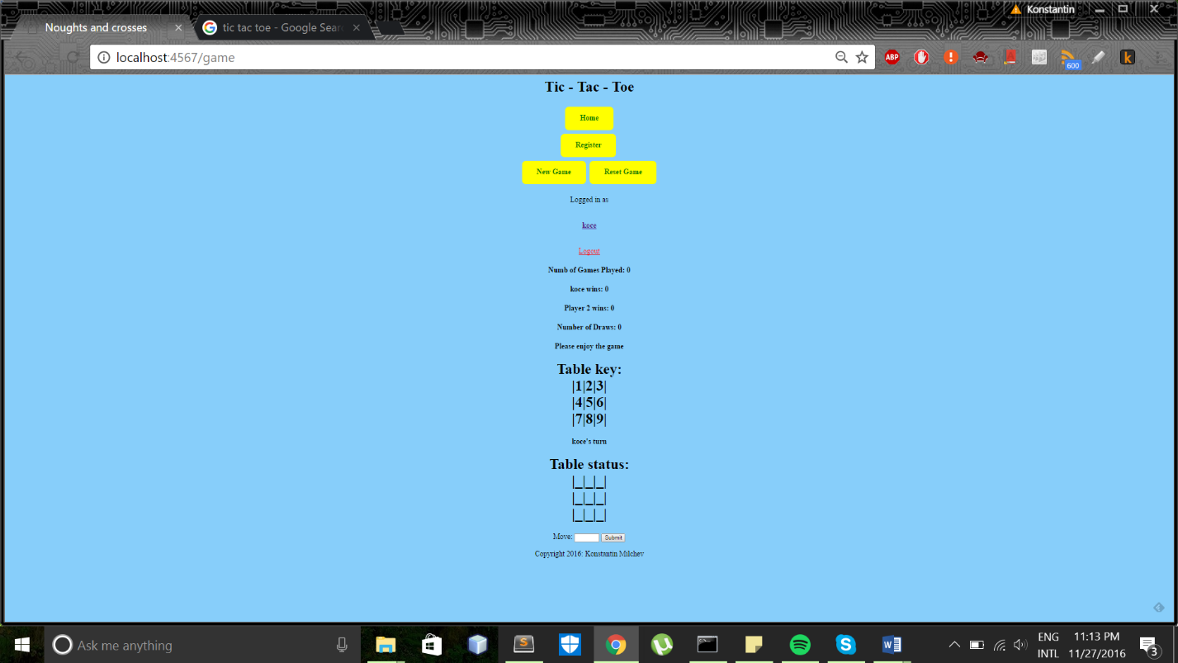

Screenshot 10

